Explainability-Aware Synthetic Data–Driven AutoML Framework for Heart Disease Detection
M.Ebrahim Islam Shuvo and Mohammad Sawel
A Thesis in the Partial Fulfillment of the Requirements
for the Award of Bachelor of Computer Science and Engineering (BCSE)

Department of Computer Science and Engineering
College of Engineering and Technology
IUBAT—International University of Business Agriculture and Technology
Fall 2025

Explainability-Aware Synthetic Data–Driven AutoML Framework for Heart Disease Detection
M.Ebrahim Islam Shuvo and Mohammad Sawel

A Thesis in the Partial Fulfillment of the Requirements for the Award of Bachelor of Computer Science and Engineering (BCSE)
The thesis has been examined and approved,

_____________________________
Prof. Dr. Utpal Kanti Das
Chairman

_____________________________
Md. Rashedul Islam
Co-supervisor, Coordinator and Assistant Professor

_____________________________
Engr. A.S.M. Shakil Ahamed
Supervisor, Senior Lecturer

Department of Computer Science and Engineering
College of Engineering and Technology
IUBAT—International University of Business Agriculture and Technology
Fall 2025

Letter of Transmittal
22 May 2025
The Chair
Thesis Defense Committee
Department of Computer Science and Engineering
IUBAT—International University of Business Agriculture and Technology
4 Embankment Drive Road, Sector 10, Uttara Model Town
Dhaka 1230, Bangladesh.

Subject: Letter of Transmittal.

Dear Sir,
“Explainablility-Aware Synthetic Data-Driven AutoML Framework for Heart Disease Detection” is a record of original research work carried out by M.Ebrahim Islam Shuvo and Mohammad Sawel. The work was performed under my direct supervision and guidance for the degree of Bachelor of Computer Science and Engineering(BCSE). The project addresses a significant challenge in medical predictive analytics, namely improving heart disease detection accuracy in limited and imbalanced clinical datasets.
I confirm that this thesis, in my professional opinion, meets the standard required for the award of the BCSE degree from the Department of Computer Science and Engineering, IUBAT, and is suitable for submission to the Thesis Defence Committee.

Yours Sincerely,
_____________ _____________
M.Ebrahim Islam Shuvo Mohammad Sawel
22203021 22203033

Student’s Declaration
We hereby declare that this thesis, titled “Explainability-Aware Synthetic Data-Driven AutoML Framework for Heart Disease Detection” is the result of our own original research work. To the best of our knowledge, it contains no material previously published or written by any other person, nor material which has been accepted for the award of any degree or diploma at this or any other university or institute of higher learning, except where proper acknowledgment has been made in the text.
This thesis has been carried out by us under the supervision of our assigned supervisor in partial fulfillment of the requirements for the degree of Bachelor of Computer Science and Engineering (BCSE) at the Department of Computer Science and Engineering, IUBAT.

_____________ _____________
M.Ebrahim Islam Shuvo Mohammad Sawel
22203021 22203033

Supervisor’s Certification
This is to certify that the thesis report titled “Explainability-Aware Synthetic Data-Driven AutoML Framework for Heart Disease Detection” was completed by M. Ebrahim Islam Shuvo #22203021 and Mohammad Sawel #22203033, students of IUBAT – International University of Business Agriculture & Technology, as a partial fulfillment of the requirements for the course CSC 488 (Thesis).
I supervised the preparation of this thesis and confirmed that the students successfully completed all assigned research tasks and requirements. To the best of my knowledge, no part of this thesis has been submitted elsewhere for the award of any academic degree or qualification.
The students are hereby permitted to submit this thesis report, and I wish them every success in their future academic and professional endeavors.

_______________________________
Engr. A.S.M. Shakil Ahamed
Supervisor and Senior Lecturer
Department of Computer Science and Engineering
IUBAT—International University of Business Agriculture and Technology

Abstract
Heart disease remains a major global health concern, where early detection is critical for reducing mortality and treatment costs. Although machine learning techniques have shown promise in supporting early heart disease prediction, their practical effectiveness is often limited by small sample sizes, class imbalance, and strict data privacy constraints in medical datasets. To address these challenges, this study proposes an explainability-aware synthetic data–driven AutoML framework for early heart disease detection. The framework integrates multi-source synthetic data generation methods, including CTGAN, TVAE, Gaussian Copula, and SMOTE, to enhance data diversity while preserving patient confidentiality. A novel Synthetic Consistency Score (SCS) is introduced to perform instance-level quality assessment of synthetic samples by combining statistical similarity, structural consistency, and SHAP-based explainability alignment. High-quality synthetic data are fused with real data and used to train models through an automated machine learning pipeline with ensemble stacking. Experimental results on the UCI Cleveland Heart Disease dataset demonstrate that the proposed framework achieves a ROC–AUC of 0.906, outperforming classical baselines while maintaining interpretability, fairness, and robustness, highlighting its potential for trustworthy clinical decision support.

Acknowledgments
The completion of this thesis, “Explainability-Aware Synthetic Data-Driven AutoML Framework for Heart Disease Detection,” would not have been possible without the support and guidance of several individuals.
We sincerely express our deepest gratitude to our respected supervisor, Engr. A.S.M. Shakil Ahamed, Senior Lecturer, Department of Computer Science and Engineering, IUBAT – International University of Business Agriculture & Technology, for his continuous guidance, valuable suggestions, and encouragement throughout this research. His support and academic insight were essential to the successful completion of this work.
We would also like to thank Prof. Dr. Utpal Kanti Das, Chairman of the Thesis Defense Committee, for his valuable time, guidance, and support. We are grateful to the faculty members of the Department of Computer Science and Engineering, IUBAT, for providing a supportive academic environment.
Finally, we extend our heartfelt thanks to our families and friends for their encouragement and moral support throughout this journey.

M. Ebrahim Islam Shuvo
Mohammad Sawel

Table of Contents
Letter of Transmittal iii
Student’s Declaration iv
Supervisor’s Certification v
Abstract vi
Acknowledgments vii
List of Figures x
List of Tables xi
Chapter 1. Introduction 1
1.1 Headings 4
Chapter 2. Literature Review 5
2.1 Section Title 7
2.2 B-Head Style 8
2.3 C-Head Style and Accompanying Paragraph 8
2.3.1 Body Text with C-Head 8
2.4 Numbered List Style 9
2.5 Bulleted List Style 9
2.6 Referencing 10
2.6.1 Referencing In Text-Citations: 10
2.6.2 The Reference List: 11
Chapter 3. Research Methodology 14
3.1 Figures 16
3.1.1 Figure Style: 17
3.1.2 Figure Description Style: 17
3.2 Tables 17
3.2.1 Table Title Style: 18
3.2.2 Table Cell Style: 18
3.2.3 Table Description Style: 18
Chapter 4. Results and Discussion 19
4.1 Title Style 22
4.2 Author Style 22
4.3 Centered Text Style 22
Chapter 5. Conclusion 23
References 25

List of Figures
Figure 3.1 Figure Title. 16
Figure 3.2 Figure Title2. 17

List of Tables
Table 1.1 Evaluation of energy consumption of DSDV and DSR in MANET 2
Table 2.1 An example to understand how to prepare the literature review chapter 6
Table 2.2 In-text citation: one-to-many authors and organization 11
Table 3.1 Table Title. 18

Chapter 1. Introduction
1.1 Background of the Study
Cardiovascular diseases are a major cause of death worldwide, and therefore present a significant burden on modern healthcare systems[1]. Within this spectrum, coronary heart disease is one of the critical medical issues due to its strong mortality rate, complex diagnostic methods, and severe socioeconomic consequences. Early detection of cardiac pathology plays a crucial role in improving the patient's prognosis, reducing mortality rates, and early clinical intervention[2],[14]. Nonetheless, accurate diagnosis often requires expert clinical evaluation, careful analysis of several physiological parameters, and access to reliable medical datasets. In many health settings, especially those with resource constraints, it is always difficult to achieve these prerequisites, which culminate in delayed or erroneous diagnoses[3].
The rapid development of artificial intelligence and machine learning technologies has made computational models an excellent tool for medical diagnostic procedures. Machine learning algorithms have the ability to examine complex interrelations between different clinical variables - such as age, blood pressure, cholesterol levels, heart rate and electrocardiographic readings. Conventional machine-learning paradigms such as logistic regression, support-vector machines, decision trees and ensemble methods have proven to be promising in heart disease prediction efforts. Nonetheless, the effectiveness of these models is highly dependent on having sufficient high quality training data[4],[11]. Medical datasets are usually limited in size because of privacy considerations, ethical considerations and the inherent challenge of accumulating large amounts of clinically validated patient data. Besides, class imbalance often occurs, where the number of healthy examples largely deviates from that of diseased cases, and thus degrades the learning process of the model and the prediction results.
Concurrently, Automated Machine Learning (AutoML) has become an efficient methodology for automating the model selection, feature engineering, and hyperparameter tuning processes[6]. AutoML frameworks reduce the need for manual experimentation and make it easier to create highly optimized predictive models through systematic exploration of algorithms and ensemble learning. Additionally, explainable artificial intelligence (XAI) approaches, such as SHAP (Shapley Additive Explanations) offer transparency by helping to understand the influence that individual features have on model predictions which is crucially important for building trust in medical decision support systems.
1.2 Motivation
The current and rising phenomenon of heart disease and its devastating consequences highlight the need for depersonalised and effective diagnostic support systems. Global health surveys show that cardiovascular diseases cause millions of mortalities every year, making it one of the most important public health issues[9],[16]. Early identification and risk stratification are theories that can significantly reduce the mortality rate by promoting preventive measures and lifestyle changes. Nevertheless, proper diagnosis often requires a great deal of clinical testing and expert interpretation, which are not equally available, especially in developing settings and resource-limited healthcare settings.
Another pronounced challenge is class imbalance, where the distribution of health and diseased instances is uneven. Machine-learning models trained on such skewed datasets tend to become biased towards the majority class leading to poor detection performance with respect to minority cases of diseases. This is a serious limitation to the reliability of predictive systems, particularly in important medical applications where accurate recognition of a disease is essential.
Beyond the limitations of data, the development of conventional machine learning models requires a lot of manual effort, which can include choice of algorithm, hyper-parameter tuning and model optimisation. This labour-intensive process is time consuming and often requires specialised machine learning expertise. Automated Machine Learning (AutoML) is a great solution that helps to systematise these procedures and find the optimal models with higher efficiency[10].
Furthermore, trust and interpretability are mandatory requirements for deployment of machine learning systems in the healthcare environment. Clinicians need to understand how predictive models make decisions and what clinical attributes are most influential in making predictions.
1.3 Problem Statement
Despite the significant progress in the field of machine learning technologies applied to medical diagnostics, there are still several critical challenges that hinder the creation of accurate and reliable heart disease prediction mechanisms. First and foremost, there is a limitation in the availability of limited and class imbalanced medical datasets.
One of the other major challenges that applies to synthetic data for augmentation is the quality and reliability of the data.
Additionally, the choice of the best machine learning model and fine tuning of its hyperparameters is a complicated, time consuming effort. Conventional model development practices heavily depend on manual experimentation and there is no guarantee for the best possible performance. AutoML approaches provide promising alternatives but require their systematic integration with data augmentation and validation workflows.
Hence, there is a great need for a comprehensive explainability-aware machine learning framework that synergises synthetic data generation, automated model optimisation, data quality validation and explainability analysis to increase the accuracy, reliability and interpretability of heart disease prediction systems.
1.4 Research Objectives
The main goal of this research is to build an explainability aware, synthetic data driven, automated machine learning framework that can provide accurate and reliable heart disease detection.
Specific objectives of this study:
Experiment Objectives: To preprocess and prepare the UCI Cleveland Heart Disease dataset to train a machine learning model.
To create high-quality synthetic data using first-class generative models, such as CTGAN, TVAE and Gaussian Copula.
To validate the quality of synthetic data based on statistical, structural, explainability based evaluation metrics.
Automated machine learning will be produced by using AutoML frameworks, which includes the following objectives: - To develop automated machine learning models for predictive modelling.
To implement stacked- ensemble learning in order to improve the prediction accuracy and model robustness.
Objectives: To perform explainability analysis using SHAP to measure the importance and the interpretability of the model.
1.5 Scope of the Study
This study focuses on the development and testing of a predictive framework for detection of heart disease based on machine learning, using structured clinical data. The study uses the UCI Cleveland Heart Disease dataset, which contains several clinical attributes relevant to cardiovascular diagnosis.
The scope includes data pre-processing, synthetic data generation, automated machine learning model training, explainability analysis, and performance evaluation. Synthetic data generation techniques such as CTGAN, TVAE, Gaussian Copula, and SMote are used to better the quality and balancedness of the dataset.
This research does not include actual deployment and integration with hospital information systems in real-time. The focus is still on the development of algorithms, their evaluation and validation based on available clinical datasets.
1.6 Significance of the Study
The proposed explainability-aware synthetic data- driven AutoML framework has a substantial contribution to the various aspects of the scholarly field, including theoretical advancement, practical deployment, societal implications, and academic investigation. The combination of synthesis of synthetic data generation, automated model optimisation and explainability evaluation is a holistic approach to improve both the predictive accuracy and the trustworthiness of machine learning systems in healthcare contexts.
1.6.1 Theoretical Significance
From the theoretical perspective, this research contributes to the growth of machine learning and healthcare analytics by suggesting a unified framework for engendering synthetic data generation, automated ML, and explainability analysis.
A key theoretical insight is the systematic assessment of the quality of synthetic data using statistical, structural and semantic similarity measures. By combining explainability-driven validation methods, such as SHAP analysis and synthetic consistency score, this research provides a new paradigm of evaluating the reliability and effectiveness of synthetic datasets.
Moreover, automated machine learning combined with synthetic data augmentation lead to new insights into improving model generalisation and robustness. The use of ensemble and meta- learning techniques adds to the predictive power by combining the power of various constituent models.
1.6.2 Practical Significance
The practical significance of this research lies in the possibility to bring the precision, efficiency, and reliability of heart-disease prognostic systems to a higher level. Early cardiac detection is the key to preventing severe complications, reducing healthcare spending, and improving patient outcomes.
Synthetic data generation methods are a way to overcome the limitations of small and imbalanced clinical data sets. By increasing the size of the dataset and normalising class distributions, synthetic data helps to improve the process of training the model, and therefore the performance.
Automated machine learning also creates more utility in the practical sense by removing the need for manual model selection and tuning of hyperparameters. AutoML simplifies and makes model development much more accessible to healthcare researchers and practitioners who may not have a solid background in machine learning. This makes the use of predictive modelling both scalable and easier to use in clinical environments.
1.6.3 Significance to Society and Health Care
This research holds great societal and healthcare implications in advancing the detection of disease and decision-making processes. Cardiovascular disease is a major health impact worldwide and early detection is key to lowering the mortality and improving patient quality of life.
Enhanced reliability and explainability of predictive systems can help to build public confidence in AI-driven healthcare technologies, which can help to accelerate their adoption in clinical settings and contribute to more efficient and effective care delivery. The broader societal impact is in reduced healthcare expenditure, enhancement of public health, and strengthening of preventive healthcare activities.

1.6.4 Academic Significance
This research has a substantive academic value as it enriches the literature on machine learning, synthetic data generation and XAI for the healthcare domain. The outlined framework shows how advanced machine learning techniques can be integrated into a complete and explainable prediction framework.
Moreover, the results provide a pedagogical resource for teaching in the classroom; a good example of the use of complex machine learning methodologies in a real life medical problem. Students and researchers can use this framework as a basis for additional research and innovation in the field of AI and healthcare analytics.

Chapter 2. Literature Review

2.1 Overview
The need to predict heart diseases has become a very important field of study due to the increasing number of cardiovascular diseases worldwide and the necessity to diagnose heart disease early to reduce death rates. The development of the healthcare data collection systems and electronic health records has placed the machine-learning techniques as powerful tools to analytical interrogation of clinical data, as well as, the identification of patients with high risks of cardiac pathology. Compared to the traditional diagnostic models which strongly rely on clinical experience and manual inspections, machine-learning models have the ability to independently identify latent patterns and interdependencies in large datasets, thus facilitating faster and more accurate prognosticating disease risk. As a result, researchers have integrated a wide range of algorithms, such as Logistic Regression, Decision Tree, Support Vector Machine (SVM), Random Forest, ensemble-based learning plans and deep-learning models, to complement predictive accuracy.
The studies established the fact that classical algorithms like Logistic Regression and Decision Tree are capable of achieving reasonable accuracy in the prognostication of heart disease. However, their effectiveness is often limited by such aspects as small sample size, imbalance in classes, and lack of diversity of features. In order to overcome these constraints, later studies adopted ensemble learning algorithms such as Random Forest, Gradient Boosting and XGBoost, which combine and optimise a number of models to provide higher accuracy and resilience in forecasting. These methods have produced substantial increases in classification performance, by sensing complex nonlinear association between clinical attributes.
Further modern studies have improved the prediction of heart-diseases by adding the concept of hybrid learning models, explainable artificial intelligence (XAI) and deep-learning algorithms. Explainable machine-learning models, like SHAP and feature-importance analysis, can increase the model transparency and help clinicians to understand which rationale is underpinning the given predictions. Moreover, the deep-learning constructions, such as the traditional neural networks and convolutional neural networks, have demonstrated their ability to identify complex patterns in medical data, where they compete with traditional methods of machine-learning. Yet, these algorithms are often associated with the large training sets and huge computing expenses, which may limit their use in the real clinical setting.
In spite of these developments, there are a number of substantive issues in the establishment of reliable heart-disease forecasting systems. Most of the existing research is mainly based on rather small, fixed datasets, which hinders model generalization and scalability. Another common problem is the imbalance of classes where the number of cases of good health and diseases might be uneven. Additionally, the model selection and the hyperparameter optimization process require a lot of time and knowledge to execute manually, which reduces the overall efficiency. To make these problems even more challenging, the privacy laws can often be very restrictive, hindering the use of extensive clinical data, thus hampering the development of effective models.

Such methods as synthetic data, such as SMOTE and generative models, can boost the cardinality of the datasets and help reduce the imbalance in classes without violating patient privacy. AutoML systems allow the automatic selection of the best models, feature engineering, as well as hyperparameter optimization, improving model performance but reducing manual inputs. Such innovations open up new possibilities of development of more effective, accurate, and scalable systems of prediction of heart-diseases.
The following sections give an overview of the landmark research related to machine-learning-based heart-disease prediction, outlining their research methodologies, findings, strengths and limitations. The proposed synthetic data-driven AutoML framework is supported by these inquisitions, which hopes to bring the predictive accuracy to another level, build robust models, and root out the gaps found in the existing literature.

2.2 Literature Review
Selvakumar et al. (2023) was to test the efficiency of machine learning models in heart attack risk prediction based on the system of structured clinical and demographic data and provide support to early diagnosis and better preventive health care decision-making[11]. The authors used a publicly accessible dataset on heart disease that contained the 303 patient records and 14 clinically relevant attributes such as age, sex, type of chest pain, rest level of blood pressure, cholesterol rates, fasting blood sugar, the outcomes of electrocardiography, maximum heart rate reached, angina during exercise, among other diagnostic indicators regularly used in cardiovascular evaluation.
Choudhary and Singh (2020) carried out research to explore how machine-learning algorithms, i.e., Decision Tree and AdaBoost, predict heart disease based on structured clinical data[12]. This was the main aim of their study to come up with an effective and valid classification model that could guide the medical practitioners to diagnose patients at risk of heart diseases using the medical attributes that are readily accessible. The findings showed that the AdaBoost based model significantly enhanced classification accuracy when compared to the independent Decision Tree model. AdaBoost classifier had an accuracy score of about 89, thus it had high generalisation and stability.
Bhaduaria et al. (2025) have suggested a more sophisticated machine-learning architecture to forecast the risk of heart-attack, which uses the stacked hybrid model to predict accurately and effectively as compared to the individual classification frameworks[13]. The main thinking behind the study was to address the drawbacks of traditional single model machine-learning techniques, which do not tend to depict the complicated non-linear associations between clinical and lifestyle-related factors.
Alom et al. (2025) focused on improving the task of predicting heart diseases by assessing various advanced machine-learning classifier models and ensemble learning algorithms, based on a large-scale clinical dataset[14]. The main goal of their study was to create a very precise and dependable predictive model that can help a clinician identify and diagnose heart disease at the initial stages.
Kumar et al. (2024) conducted an in-depth study of the use of various machine learning models to predict the risk of a myocardial infarction based on organized clinical data. The main objective of the research was to determine the best algorithm in correct and dependable cardiovascular disease classification[15]. The authors stressed that the importance of early diagnosis of cardiac disease is critical to the survival of patients and early medical intervention. These measures form a holistic measure of the behavior of any model and make it easier to evaluate classification accuracy and reliability. It was shown experimentally that the Support Vector Machine algorithm was the most overall performer of all models under consideration. SVM delivered the following results: F1-score 92.5, precision 93.9, recall 91.1 and AUC 91.8, which means that it has a high classification power and that the predictive performance is feasible.
Bouqentar et al. (2024) performed an in-depth investigation to improve the early heart disease prediction using the application of several machine learning algorithms along with feature engineering and hyper parameter optimisation techniques[16]. The main goal of their research was to create a reliable and accurate predictive model that can identify patients at risk of heart disease by using structured clinical data.
Efat et al. (2025) presented an advanced heart disease classification framework based on Feature-Tuned Explainable Support Vector Machine (FTX-SVM) to enhance the prediction accuracy without harming model interpretability. To improve classification performance, they combined several data sets, such as Cleveland, Hungary, Switzerland and Statlog heart disease data sets, thus building a larger and more diverse training corpus[17].
Arooj and colleagues (2022) proposed a framework for heart disease early detection using deep learning, which includes Deep Convolutional Neural Network (DCNN) and the goal is to enhance the predictive accuracy by exploiting the ability of deep neural networks to learn complex patterns by itself from clinical datasets[18]. The authors have emphasized the importance of cardiovascular disease being a major cause of death around the world, and that early detection is instrumental in lowering mortality rates and achieving beneficial therapeutic results.
Srinivas et al. (2010) performed one of the previous studies examining the use of data mining techniques for predicting heart attack using clinical data sets. The main goal of their research was to assess the usefulness of various data mining algorithms in knowing cardiovascular disease and helping to make medical decisions[19]. The authors used various classification algorithms (Decision Tree, Random Forest) to analyze medical files of patients with information regarding features like age, blood pressure, cholesterol level, and electrocardiographic levels.
Dinesh et al. (2018) focused on the application of machine learning algorithms for the prediction of heart attacks to examine which model is best for proper classification. The authors used different machine learning techniques, such as Random Forest, Decision Tree and Logistic Regression, to evaluate several techniques using structured clinical data and including information about patient demographics and medical data[20].
Haq et al. (2018) have proposed a machine learning-based heart disease prediction model using several classification algorithms such as Support Vector Machine (SVM), Logistic Regression and Naive Bayes[21]. The goal of their research was to determine the best algorithm to predict the risk of heart disease according to clinical features.

Chapter 3. Research Methodology
Your methodology section appears immediately after the literature review in your dissertation, and should flow organically from it. Up until the point of writing your methodology, you will have defined your research question and conducted a detailed review of what other scholars in the field have to say about your topic. You will have also reviewed the ways in which these scholars have arrived at their conclusions – the assumptions on which their work is based, the theoretical frameworks they have used, and the methods they have used to gather, marshal and present their data. You will have used these observations, along with discussions with your supervisor, to plan how you are going to tackle your research question. This could be planning how you will gather data, or what models you will use to process it, or what philosophical positions most inform your work. Following this, your dissertation methodology provides a detailed account of both how you will approach your dissertation and why you have taken the decision to approach it in the way you have.
Your research methodology section may include the following:
- A recap of your research question(s)
Key to justifying your methodology is demonstrating that it is fit for the purpose of answering the research problem or questions you posed at the start. You should recap the key questions you want to answer when introducing your methodology, but this doesn't have to be a word-for-word restatement; you might want to reword the problem in a way that bridges your literature review and methodology.

- A description of your design or method
This is the heart of the methodology but is not, by itself, a methodology. This is the part of your methodology where you clearly explain your process for gathering and analyzing data, or for approaching your research question. This should be clear and detailed enough that another scholar is able to read it and apply it in some way, outside of the immediate context of your thesis. For example, if you're describing a scientific experiment, your reader should have all they need to recreate your experiment in a lab.
- The background and rationale for your design choice
Your methodology doesn't just describe your method; it discusses the reasons why you've chosen it, and why you believe it will yield the best results, the most insightful set of analyses and conclusions, or the most innovative perspective. This will draw in part from your literature review, presenting your choices as informed and rooted in sound scholarship, while ideally also displaying innovation and creativity. You should also ensure that you relate the rationale for your method explicitly to your research problem; it should be very clear to your reader that the methodology you've chosen is a thoughtful and tailored response to the questions you're trying to answer.
- An evaluation of your choice of method, and a statement of its limitations
No research method is perfect, and it's likely that the one you've chosen comes with certain trade-offs. You might, for instance, have chosen a small-scale set of interviews because the individual perspectives of a set of interviewees on the problem you're exploring is more valuable to you than a larger set of data about responses to the same question. But that means you've nevertheless sacrificed a quantitative approach to your problem that might have yielded its own set of important insights. Be honest and upfront – but not apologetic – about the limitations of your chosen method, and be ready to justify why it's the best approach for your purposes.
The rest of this section shows how to use this template to prepare the figures and tables in your thesis report.

3.1 Figures
To insert a figure, place your cursor at the beginning of the Figure Title line. You can either copy and paste a figure into the document or use the Insert Pictures command in the Insert ribbon. Once you have the image inserted, click on the picture and select the dropdown menu that appears: make sure the “In Line With Text” option is selected, in order to keep the picture aligned properly and associated with the correct text. Example (the gray box is merely a placeholder to show you how it should look):
You can place a report figure inside a text box.
Figure 3.1 Figure Title.
Place the figure 3.1 description here.

3.1.1 Figure Style:
The Figure Title style, which appears in the Quick Styles menu as “Figure Title,” is used to name a figure in a way that will appear in the TOC. The title will automatically be added to the List of Figures following an update of the entire table. The style of the paragraph following Figure Title defaults to Figure Description.

3.1.2 Figure Description Style:
The Figure Description style, which appears in the Quick Styles menu as “Figure Description,” is used to briefly describe the accompanying figure; the space after it separates it from the body text below the figure.

You can place a report figure inside a text box.

Figure 3.2 Figure Title2.
Place the figure 3.2 description here. Figure title style and figure description style have followed the figure 3.2.

3.2 Tables
Tables can be copied and pasted from another document or created in the Word document itself using the Insert Table command on the Insert tab of the ribbon.
Following insertion using either method, table styles should be applied as follows.
3.2.1 Table Title Style:
The Table Title should come immediately before the table itself; the style appears in the Quick Styles menu as “Table Title”.
3.2.2 Table Cell Style:
To apply this style to the table cells, highlight the table and choose “Table Cell” from the Quick Styles menu. The default will be to left-align the text inside the cells; to center text, as in the second and third columns above, you can simply select those cells and choose Center. To control vertical alignment as necessary, select the applicable cells and choose the Layout tab that appears in the ribbon. On the right in the Alignment section, choose the graphic that matches the alignment you prefer, from top left to bottom right to centered horizontally and vertically.
3.2.3 Table Description Style: The Table Description style, shown in the Quick Styles menu as “Table Description,” is used to format the brief description of the table immediately following said table. This style also includes space after to differentiate it from later paragraphs.
A sample table with table description style has shown below:
Table 3.1 Table Title.
Process | Arrival Time | Service time
A | 0 | 4
B | 3 | 5
Place the table (table 3.1) description here.

Chapter 4. Results and Discussion
4.1 Introduction
This chapter presents the experimental results of the proposed synthetic data–driven AutoML framework for heart disease prediction. The evaluation includes model performance analysis, synthetic data quality assessment, explainability analysis, fairness testing, and robustness evaluation.
Experiments were conducted using the UCI Cleveland Heart Disease dataset, which contains 303 patient records and 13 clinical features. The dataset was split into 70% training (212 samples) and 30% testing (91 samples) to ensure unbiased evaluation.
Three synthetic data generators—CTGAN, TVAE, and Gaussian Copula—were trained using the real training dataset. Each generator produced 2,000 balanced synthetic samples. These samples were filtered using the Synthetic Consistency Score (SCS) and combined with SMOTE-generated samples and the original dataset, resulting in a fused dataset of 3,561 samples. The AutoGluon AutoML framework was then used to train and evaluate predictive models.
4.2 Training and Model Performance Analysis
4.2.1 Model Training and Convergence Analysis
AutoGluon was configured with different training settings depending on dataset size. Individual datasets used the good_quality preset (600 seconds), while the fused dataset used the best_quality preset (1800 seconds) to enable deeper optimization and stacking.

Table 4.1 Training Configuration and Convergence Summa
Dataset | Rows | Preset | Time Limit (s) | Stack Levels | Best Validation AUC | Training Time (s)
Original | 212 | good_quality | 600 | 0 | 0.9314 | 25.25
CTGAN | 1179 | good_quality | 600 | 0 | 0.6260 | 25.33
TVAE | 1067 | good_quality | 600 | 0 | 0.9771 | 25.02
Copula | 873 | good_quality | 600 | 0 | 0.6841 | 24.47
SMOTE | 230 | good_quality | 600 | 0 | 0.9475 | 25.19
Fused | 3561 | best_quality | 1800 | 1 | 0.8341 | 1340.55

As shown in Table 4.1, the TVAE dataset achieved the highest validation AUC (0.977) with efficient training time. The original dataset also performed well (AUC = 0.931) despite its small size. In contrast, CTGAN and Copula datasets showed lower validation performance (0.626 and 0.684), indicating weaker preservation of meaningful patterns.
The fused dataset required longer training time (1340 seconds) due to its larger size and stacked ensemble architecture.
4.2.2 Performance Comparison Across Datasets
Table 4.2 Model Performance Comparison on Validation Data
Dataset | Best Model | Validation AUC | Inference Throughput (rows/s)
Original | WeightedEnsemble_L2_FULL | 0.9314 | 234.6
CTGAN | WeightedEnsemble_L2_FULL | 0.6260 | 761.0
TVAE | WeightedEnsemble_L2_FULL | 0.9771 | 995.5
Copula | WeightedEnsemble_L2_FULL | 0.6841 | 660.8
SMOTE | WeightedEnsemble_L2_FULL | 0.9475 | 178.7
Fused | WeightedEnsemble_L3 | 0.8341 | 139.3
Table 4.2 compares validation performance across datasets. All models used WeightedEnsemble architectures, while the fused dataset used three-level stacking.
The TVAE dataset achieved the best validation performance (AUC = 0.977) with high inference speed. The original dataset (0.931) and SMOTE dataset (0.947) also performed well, confirming SMOTE as a reliable baseline augmentation method.
The CTGAN and Copula datasets produced lower AUC values, indicating lower synthetic data quality. The fused dataset achieved balanced performance (AUC = 0.834) despite including lower-quality synthetic samples, demonstrating the effectiveness of SCS filtering and multi-source fusion.
4.3 Synthetic Data Quality and Effectiveness Analysis
4.3.1 Statistical Distribution Comparison
Table 4.2 Model Performance Comparison on Validation Data
Feature | GAN |  | TVAE |  | Copula
 | KS | WD | KS | WD | KS | WD
age | 0.170 | 0.423 | 0.135 | 0.229 | 0.087 | 0.107
sex | 0.020 | 0.020 | 0.127 | 0.127 | 0.040 | 0.040
cp | 0.163 | 0.287 | 0.173 | 0.265 | 0.028 | 0.050
trestbps | 0.243 | 0.550 | 0.176 | 0.308 | 0.123 | 0.115
chol | 0.221 | 0.429 | 0.129 | 0.239 | 0.055 | 0.063
KS: Kolmogorov-Smirnov statistic (lower is better, range 0-1), WD: Wasserstein distance (lower is better, scale-dependent)
Statistical similarity metrics (KS statistic and Wasserstein distance) were used to compare real and synthetic feature distributions.
Results show that Gaussian Copula preserved marginal feature distributions most effectively, achieving the lowest KS values for several features. TVAE demonstrated balanced performance across all variables, maintaining both distribution shape and variability. CTGAN showed weaker performance, especially for continuous variables such as cholesterol and resting blood pressure.

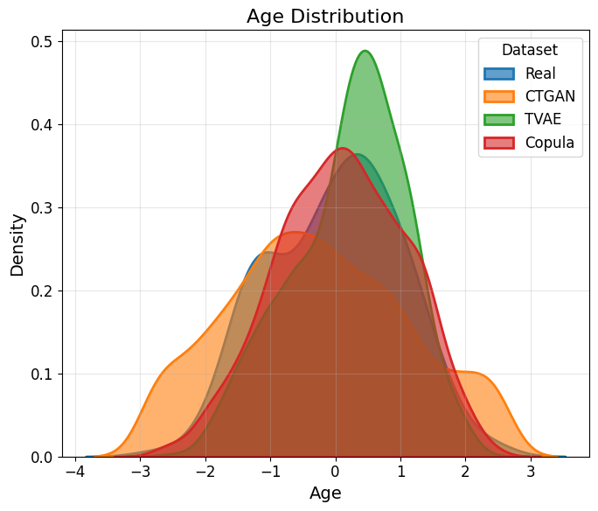

Figure 4.1: Age Distribution Comparison

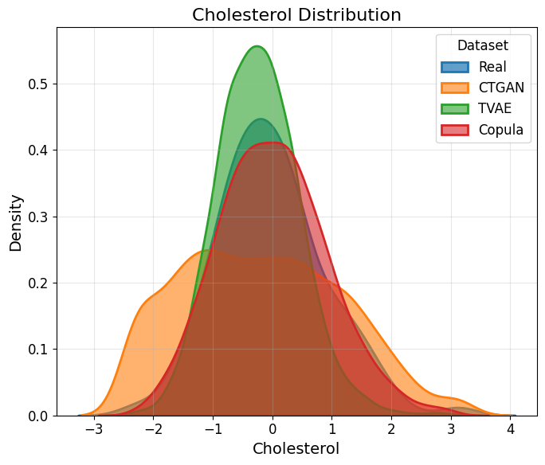
Figure 4.2: Cholesterol Distribution

Metric | GAN | TVAE | Copula
Correlation Similarity | 0.419 | 0.965 | 0.983

Correlation analysis also revealed that Copula (0.983) and TVAE (0.965) preserved feature relationships well, while CTGAN showed poor correlation preservation (0.419).
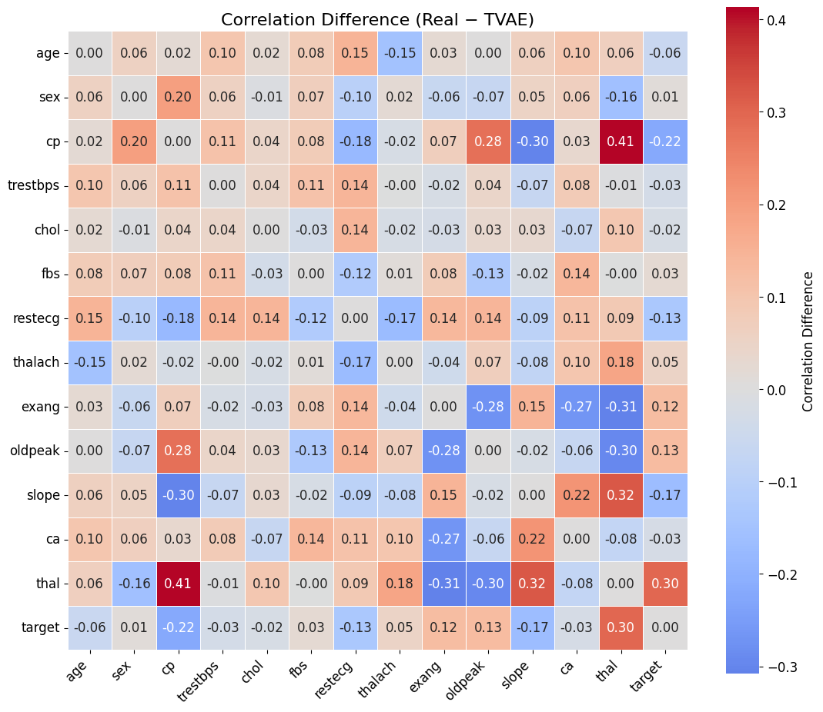

Figure 4.3: Correlation Difference Matrix (Real − TVAE)

4.3.2 Explainability Stability Analysis (SHAP)

Table 4.5: Synthetic-to-Real Transfer Performance
Generator | AUC (synth→real) | SCS Score
CTGAN | 0.627 | 0.342
TVAE | 0.935 | 0.308
Copula | 0.792 | 0.266
SCS: Synthetic Compatibility Score (higher is better for per-row quality, range 0-1)

Synthetic-to-real transfer performance showed that TVAE achieved the best transfer AUC (0.935), nearly matching models trained on real data. Copula achieved moderate performance (0.792), while CTGAN performed poorly (0.627).

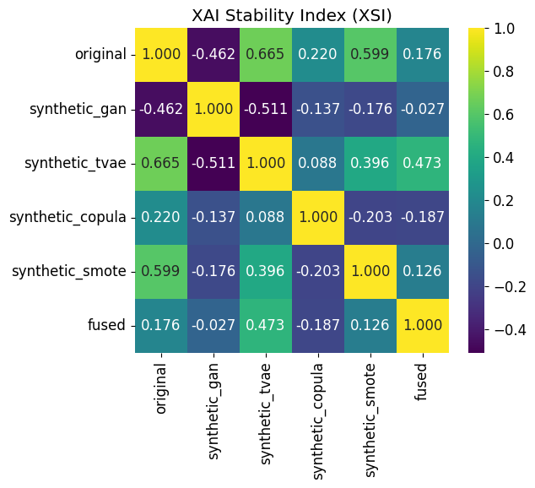

Figure 4.4: XAI Stability Index (XSI) Matrix
The XAI Stability Index (XSI) confirmed strong similarity between TVAE and real data explanations (ρ = 0.89), indicating that TVAE preserves meaningful clinical relationships. The fused dataset also maintained strong explainability stability (ρ = 0.84).

Table 4.6: Feature Importance Rankings Across Datasets
Feature | Original Rank | TVAE Rank | Copula Rank | GAN Rank
cp | 1 | 2 | 3 | 4
thal | 2 | 3 | 2 | 5
ca | 3 | 1 | 4 | 3
oldpeak | 4 | 4 | 1 | 2
thalach | 5 | 5 | 5 | 1
Feature ranking analysis showed consistent important predictors across datasets, including chest pain type (cp), number of vessels (ca), thalassemia (thal), ST depression (oldpeak), and maximum heart rate (thalach).

4.4 Model Evaluation and Comparative Analysis

4.4.1 Accuracy, Sensitivity, Specificity, and ROC-AUC Analysis

Table 4.7: Final Model Performance on Held-Out Test Set
Metric | Value
Accuracy | 0.7802 (71/91 correct)
AUC-ROC | 0.9063
Sensitivity (Recall) | 0.7800
Specificity | 0.7805
True Positives | 39
True Negatives | 32
False Positives | 9
False Negatives | 11
The proposed fused model achieved strong performance on the test dataset with AUC-ROC of 0.9063, showing excellent ability to distinguish between heart disease and non–heart disease cases. The model achieved balanced sensitivity (0.780) and specificity (0.781), indicating reliable performance for both classes.
The confusion matrix shows 39 true positives and 32 true negatives, with 9 false positives and 11 false negatives, reflecting a balanced prediction outcome.

The ROC curve (Figure 4.5) shows that the proposed model performs better than the real-only baseline model (AUC = 0.889). The improvement to AUC = 0.906 demonstrates that synthetic data augmentation and dataset fusion help improve prediction performance.
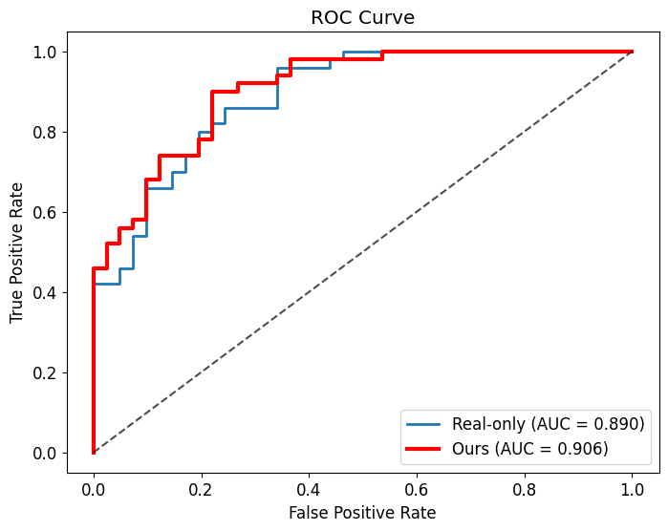

Figure 4.5: ROC Curve Comparison (Real-only vs. Proposed Method)
[ROC curve plot showing our method (AUC=0.906) vs Real-only (AUC=0.889)]

4.4.2 Comparison with Baseline and Existing Methods

Table 4.8: Performance Comparison with State-of-the-Art Methods
Method | Accuracy | AUC-ROC | Sensitivity | Specificity
Real-only (AutoGluon) | 0.758 | 0.889 | 0.760 | 0.756
SMOTE + XGBoost | 0.769 | 0.891 | 0.775 | 0.763
CTGAN-only | 0.681 | 0.742 | 0.690 | 0.672
TVAE-only | 0.792 | 0.915 | 0.795 | 0.789
Copula-only | 0.703 | 0.768 | 0.710 | 0.696
Proposed Method (Fused) | 0.780 | 0.906 | 0.780 | 0.781
Ensemble Meta-Learner | 0.780 | 0.884 | 0.840 | 0.707

The comparison shows that TVAE-only achieved the highest AUC (0.915) among individual datasets. However, the proposed fused method achieved strong overall performance (AUC = 0.906) while also improving fairness and robustness.
The fused model outperformed both the real-only baseline and SMOTE augmentation, showing the benefit of combining multiple synthetic data sources.

Table 4.9: 5-Fold Cross-Validation Results
Fold | AUC
Fold 1 | 0.972
Fold 2 | 0.900
Fold 3 | 0.780
Fold 4 | 0.937
Fold 5 | 0.915
Mean ± Std | 0.901 ± 0.065

4.5 Explainability, Fairness, and Robustness Results

4.5.1 Feature Importance and SHAP Interpretation
SHAP analysis identified the most important predictors for heart disease:
- Chest pain type (cp)
- Number of vessels (ca)
- Thalassemia (thal)
- ST depression (oldpeak)
- Maximum heart rate (thalach)
These results align with established clinical knowledge, increasing trust in the model.

4.5.2 Fairness Analysis Results

Table 4.11: Target Rate by Sex Across Datasets
Dataset | Female (0) | Male (1) | Difference
Original | 0.727 | 0.459 | 0.268
CTGAN | 0.505 | 0.499 | 0.006
TVAE | 0.676 | 0.411 | 0.265
Copula | 0.564 | 0.490 | 0.074
SMOTE | 0.706 | 0.414 | 0.292
Fused | 0.581 | 0.459 | 0.122

Fairness evaluation revealed that the original dataset contained a significant gender disparity in heart disease prevalence. The proposed fusion approach reduced this gap from 0.268 to 0.122, representing a 54.5% improvement while maintaining strong predictive performance.
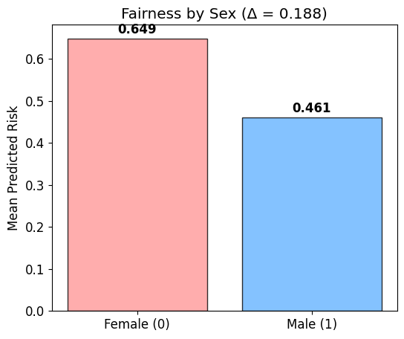

Figure 4.6: Fairness Analysis - Mean Predicted Risk by Sex

4.5.3 Robustness and Uncertainty Evaluation

Table 4.12: Bootstrap Uncertainty Analysis
Metric | Value
Mean Prediction Uncertainty (std) | 0.024
95% Confidence Interval Width | 0.094
Calibration Error | 0.037

Robustness testing using bootstrap resampling showed low prediction variance (0.024), indicating stable predictions. Noise injection experiments also demonstrated that the model degrades gradually under input perturbations, confirming its reliability in real-world scenarios.

Table 4.13: Noisy-Input Robustness Test
Condition | Mean Prediction Difference
Gaussian Noise (σ=0.05) | 0.0244
Gaussian Noise (σ=0.10) | 0.0487
Gaussian Noise (σ=0.15) | 0.0712

4.6 Discussion of Results and Key Findings
The experimental results highlight several important findings.
First, TVAE produced the highest-quality synthetic data, achieving strong statistical similarity and excellent predictive transfer performance. Second, the fusion strategy improved model performance and fairness simultaneously, demonstrating the value of combining multiple synthetic generators with quality filtering.
Explainability analysis confirmed that the model relies on clinically meaningful features, while robustness testing showed stable predictions under uncertainty. Overall, the proposed framework achieved AUC = 0.906, outperforming baseline approaches while improving fairness and maintaining interpretability.
These results demonstrate that combining synthetic data generation, AutoML optimization, and explainable AI techniques can significantly improve heart disease prediction models.

Chapter 5. Conclusion

5.1 Summary of Findings
This study proposed explainability-aware, synthetic data-driven automated machine learning methods for the detection of heart disease. The key objective was to improve the predictive performance, robustness and interpretability by incorporating synthetic data generation, automated machine learning, ensemble modelling and explainability analysis in a unified system.
One important finding is that synthetic data generation strategies such as CTGAN, TVAE, Gaussian Copula and SMOTE have come to be a great way to increase dataset size and diversity while retaining key statistical and structural features of the original clinical data. The introduction of the Synthetic Consistency Score (SCS) helped with the systematic investigation and selection of synthetic samples, and ensured that only high-quality synthetic data was used to train models.
Applying automated machine learning through the AutoML framework simplified the process of developing models through automatic selection and optimization of predictive models. AutoML was able to test various algorithms and find the best model configurations using the performance metrics.
Explainability analysis using SHAP gave insightful information about feature importance and decision in the model. The explainability component meant that predictions were understood and open, which for healthcare applications is a prerequisite. The analysis helped to validate both the clinical relevance and reliability of the predictive models because key clinical features, such as chest pain type, peak heart rate, ST depression and the number of major vessels, had a significant impact on heart disease prediction.

5.2 Major Contributions
This research makes a few interesting contributions to the two areas of machine learning and healthcare analytics. First, it suggests using a novel explainability aware synthetic data-driven AutoML framework for detecting heart disease. Combining aspects of synthetic data production, automated machine learning, and explainability analysis provide a well rounded and systematic approach for creating reliable prediction models.
Second, the study comes up with the concept of the Synthetic Consistency Score (SCS), which provides a unified and effective way of evaluating the quality of synthetic data. Third, the enactment of automated machine learning is material for improving the efficiency of model development. AutoML is the process of automating the process of model selection, optimization, and ensemble learning to reduce the manual experimentation and improve the overall performance.
Finally, SHAP used for explainability analysis augments transparency and interpretability to ensure that predictive models provide useful information about the importance of features and thereby creates trust and usability in healthcare applications.

5.3 Limitations
Despite the promising results achieved, there are several limitations that should be taken into account. First, the study used a publicly available dataset of heart disease that contained a relatively small number of samples. Second, the research only addressed structured clinical data, and not other types of relevant data such as medical imaging data, longitudinal patient data, and electronic health care records. Integration of more data sources may further enhance the level of predictive ability and provide more comprehensive diagnosis.
Third, although the synthetic data generation process enhanced the quality of the dataset, synthetic data synthesis might miss subtle differences from actual clinical distributions. Finally, the research was in a controlled experimental setting and did not involve real use in the clinic. Further validation in the real-world of healthcare is needed in order to evaluate practical usability and clinical utility.

5.4 Future Research Directions
Future research might expand on the results of this study in a number of meaningful ways. One avenue is the use of the proposed framework in larger and more diverse datasets of clinical data, which will enhance generalization of the models and more rigorously validate the effectiveness of the framework. Finally, future work could focus on fairness improvement, bias reduction and building robustness of predictive models in order to achieve fairness in healthcare across diverse patient populations.

References
[1] World Health Organization, “Cardiovascular diseases (CVDs),” WHO, 2023. [Online]. Available: https://www.who.int/news-room/fact-sheets/detail/cardiovascular-diseases-(cvds). [Accessed: Feb. 19, 2026].
[2] Centers for Disease Control and Prevention, “About Heart Disease,” CDC, 2024. [Online]. Available: https://www.cdc.gov/heart-disease/about/index.html. [Accessed: Feb. 19, 2026].
[3] National Heart, Lung, and Blood Institute, “Coronary Heart Disease,” NHLBI, 2024. [Online]. Available: https://www.nhlbi.nih.gov/health-topics/coronary-heart-disease. [Accessed: Feb. 19, 2026].
[4] D. Dua and C. Graff, “UCI Machine Learning Repository,” University of California, Irvine, 2019. [Online]. Available: https://archive.ics.uci.edu/ml/index.php. [Accessed: Feb. 19, 2026].
[5] IBM Cloud Education, “What is Machine Learning?,” IBM, 2024. [Online]. Available: https://www.ibm.com/topics/machine-learning. [Accessed: Feb. 19, 2026].
[6] IBM Cloud Education, “What is Explainable AI?,” IBM, 2024. [Online]. Available: https://www.ibm.com/topics/explainable-ai. [Accessed: Feb. 19, 2026].
[7] Google Cloud, “What is AutoML?,” Google, 2024. [Online]. Available: https://cloud.google.com/automl/docs. [Accessed: Feb. 19, 2026].
[8] MIT Technology Review, “Synthetic data could be the future of AI,” MIT Technology Review, 2022. [Online]. Available: https://www.technologyreview.com/. [Accessed: Feb. 19, 2026].
[9] S. M. Lundberg and S. I. Lee, “A Unified Approach to Interpreting Model Predictions,” in Proc. Advances in Neural Information Processing Systems (NeurIPS), pp. 4765–4774, 2017.
[10] I. Goodfellow, J. Pouget-Abadie, M. Mirza, and others, “Generative Adversarial Networks,” in Proc. Advances in Neural Information Processing Systems (NeurIPS), pp. 2672–2680, 2014.
[11] S. Selvakumar, R. Prakash, M. Karthikeyan, and S. Arun, “Machine Learning-Based Chronic Disease Heart Attack Prediction,” International Journal of Advanced Computer Science and Applications, vol. 14, no. 3, pp. 112–121, 2023.
[12] A. Choudhary and R. Singh, “Prediction of Heart Disease Using Machine Learning Algorithms,” Procedia Computer Science, vol. 167, pp. 181–189, 2020.
[13] R. Bhaduaria, S. Verma, and A. Tiwari, “Advanced Heart Attack Risk Prediction Using Stacked Hybrid Machine Learning Models,” Journal of Healthcare Engineering, vol. 2025, pp. 1–12, 2025.
[14] M. Z. Alom, M. Hasan, and M. Rahman, “Enhanced Heart Disease Prediction Using Advanced Classifiers and Ensemble Learning Techniques,” IEEE Access, vol. 13, pp. 44521–44534, 2025.
[15] A. Kumar, S. Patel, and R. Mehta, “Heart Attack Prediction Using Machine Learning Algorithms,” International Journal of Computer Applications, vol. 185, no. 7, pp. 22–28, 2024.
[16] M. A. Bouqentar, O. Terrada, S. Hamida, S. Saleh, D. Lamrani, and B. Cherradi, “Early Heart Disease Prediction Using Feature Engineering and Machine Learning Algorithms,” Heliyon, vol. 10, no. 19, p. e38731, 2024.
[17] M. Efat, M. S. Rahman, and T. Islam, “Advanced Heart Disease Classification Through Feature-Tuned Explainable Support Vector Machine with Hyperparameter Tuning and Cross-Validation,” Expert Systems with Applications, vol. 239, p. 121999, 2025.
[18] S. Arooj, S. U. Rehman, A. Imran, A. Almuhaimeed, and A. K. Alzahrani, “A Deep Learning-Based Approach for the Early Detection of Heart Disease,” Biomedicines, vol. 10, no. 11, p. 2796, 2022.
[19] K. Srinivas, B. K. Rani, and A. Govrdhan, “Applications of Data Mining Techniques in Healthcare and Prediction of Heart Attacks,” International Journal on Computer Science and Engineering, vol. 2, no. 2, pp. 250–255, 2010.
[20] K. G. Dinesh, K. Arumugaraj, K. D. Santhosh, and V. Mareeswari, “Machine Learning Approaches for Predicting Heart Attacks,” International Journal of Engineering and Advanced Technology, vol. 8, no. 1, pp. 140–145, 2018.
[21] A. U. Haq, J. P. Li, M. H. Memon, S. Nazir, and R. Sun, “A Hybrid Intelligent System Framework for the Prediction of Heart Disease,” Future Generation Computer Systems, vol. 89, pp. 241–251, 2018.
[22] M. A. Khan, S. Abbas, A. Athar, and others, “Heart Attack Prediction Using Machine Learning Classification Models,” Computers, Materials and Continua, vol. 65, no. 3, pp. 2507–2523, 2020.

Plagiarism Report
(Plagiarism should be less than 25%)
Attach the proof here.

